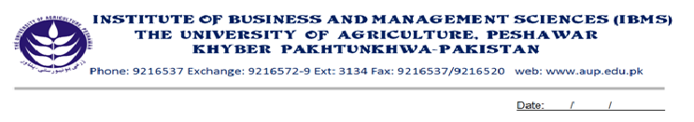
Program: BS (CS)-VII
Course Title: Visual Programming - II
Course Code: CS-603
Session: 2009-2012
Course Hours: 03
Total Week: 16
Total Credit Hours: 48

Course Objectives:
The aim of this course is to teach a full object oriented programming overviews and specially getting expertise in vb.net applications programming. In this course students will learn about vb.net GUI Environment of the vb.net and built in ActiveX.net classes. This course also covers the access SQL Server’s Database with the help of Vb.net Environment. After completion of this course students will be able to accomplish their final projects easily.

Week 1
- Timer Control
- Properties and Methods
- Enabled, Interval, Start, Stop
- Progress Bar
-Properties and Methods
- Maximum, Minimum, Step, Value

Week 2
- Creating Multi Document Interfaces
- MDI Parents
- MDI Childs
- Adding Menus in MDI Forms

Week 3
- Working with files and Directories
- Directory Creation
- Copy files
- Renaming files
- Deleting files

Week 4
- Use of Notify Icon
- Context Menu
- Tab Control
- Error Provider Control

Week 5
- Installation of SQL Server
- Use of Enterprise Manger
- Use of Query Analyzer

Week 6
- Database Creation
- Tables Creation
- Using Enterprise Manager & Query Analyzer

Week 7
- Working with DML Statements
- Insert
- Delete
- Update

Week 8
- SQL Server joins statements
- Cross-Join
- Inner Join
-Full Outer Join

Week 9
- Stored Procedures & Their Use
- Creation of Store Procedures in
- Enterprise Manager
- Query Analyzer

Week 10
- Ado.net Object
- OLEDB Connection
- OLDDB Data Adapter
- OLEDB Command
- Dataset

Week 11
- Working with Data grid
- Bind it with Ms-Sql Server Tables

Week 12
- Bind the following Controls
- Buttons
- Text boxes
- List boxes

Week 13
- Develop a Database Application Using Coding Method
- Creating Connections
- Data Binding
- Navigation Among Records
  - First
  - Last
  - Previous
  - Next

Week 14
- Perform Data Manipulation Using Ado.net Coding Methods
- Add New Records
- Delete Records
- Update Records
- Search a Particular Record

Week 15
- History of Crystal Reports
- Working with Crystal Reports
- Different Section Of Crystal Reports
- Use of Record Selection Formula
- Crystal Report Viewer

Week 16
- Project

Total Marks: 100

Recommended Books

- Vb.net Bible by Bill Evjen, Jason Bores
- Mastering Vb.net by Sybex
- Beginning Visual Basic.net by Wrox

